# **7. IPv4_Addressing_Part1**

**The OSI Model – Network Layer (Layer 3)**

* **Purpose:**
  + Enables connectivity between end devices on **different networks** (beyond a LAN).
  + Provides **logical addressing** (IP addresses) and selects paths from **source to destination**.
* **Devices at Layer 3:**
  + **Routers:** Operate at this layer and separate different networks.

### **Routing**

* **Switches (Layer 2):**
  + Connect devices within the same LAN but do **not separate networks.**
* **Routers (Layer 3):**
  + Connect multiple LANs and split networks, assigning each LAN a **unique IP network address.**
  + Example:
    - **Network 1:** 192.168.1.0/24 (Subnet Mask: 255.255.255.0).
    - **Network 2:** 192.168.2.0/24.
* **Router Interface IPs:  
   v**
  + Each interface on a router connects to a specific LAN and has its own IP address:
    - **G0/0 (LAN1):** 192.168.1.254/24.
    - **G0/1 (LAN2):** 192.168.2.254/24.
* **Broadcast Behavior:**
  + A broadcast stays within its LAN and does not cross a router.

### **IPv4 Addressing and Headers**

* **IPv4 Address Format:**
  + **32-bit binary number** split into 4 octets.
  + Represented in **dotted decimal format** (e.g., 192.168.1.254).
* **Binary Conversion Example:**
  + IP: 192.168.1.254.
  + Binary: 11000000.10101000.00000001.11111110.
  + Each octet corresponds to 8 bits (values: 128, 64, 32, 16, 8, 4, 2, 1).
* **Field Details in IPv4 Header:**
  + Contains **source IP address** and **destination IP address.**

### **Decimal to Binary Conversion**

1. Example: **221**
   * Subtract the value of each binary slot from the decimal number:
     + 221 - 128 = 93 → **1** in the 128 slot.
     + 93 - 64 = 29 → **1** in the 64 slot.
     + 29 - 32 is not possible → **0** in the 32 slot.
     + Continue: 11011101.
2. Example: **127**
   * Result: 01111111.

### **IPv4 Address Components**

* **Network Portion and Host Portion:**
  + Represented by the **prefix length** (e.g., /24).
  + /24 means the first 24 bits are the **network portion.**
    - Example: 192.168.1.0/24 → Network: 192.168.1, Host: last octet.

### **IPv4 Address Classes**

* **Classes:** Determine the structure of the network portion.
  + **Class A:**
    - Range: 0-126 (127 is reserved for loopback: used to test the ‘network stack’ (think OSI, TCP/IP model) on the local device).
    - Network Prefix: /8.
    - Netmask: 255.0.0.0.
  + **Class B:**
    - Range: 128-191.
    - Network Prefix: /16.
    - Netmask: 255.255.0.0.
  + **Class C:**
    - Range: 192-223.
    - Network Prefix: /24.
    - Netmask: 255.255.255.0.
  + **Class D:** Reserved for **multicast addresses.**
  + **Class E:** Reserved for **experimental purposes.**

### **Network Address and Broadcast Address**

* **Network Address:**
  + Host portion = all **0s.**
  + Example: 192.168.1.0/24.
  + Identifies the network itself and **cannot** be assigned to hosts.
* **Broadcast Address:**
  + Host portion = all **1s.**
  + Example: 192.168.1.255.
  + Used to send packets to **all devices** in the network.
* **Usable Host Addresses:**
  + Range: **1 to 254** in a /24 subnet.
  + Two addresses (network and broadcast) are reserved.

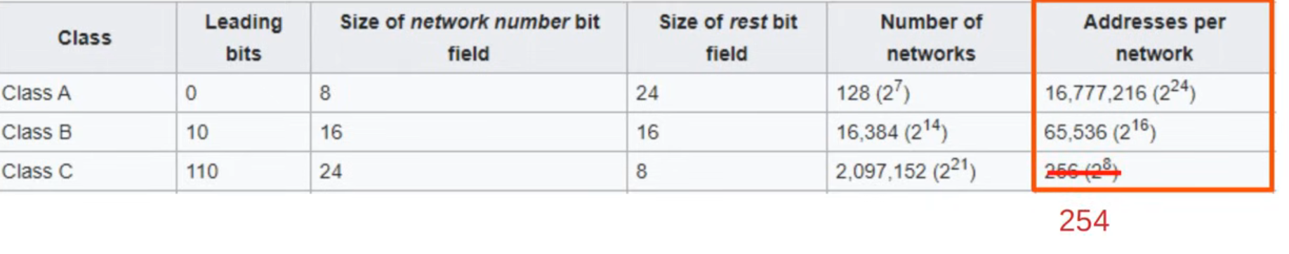

### **Examples of Binary to IPv4 Conversion**

1. **Binary:** 10011010010011100110111100100000  
   * Octets: 154.78.111.32.
   * Prefix: /16 → Network: 154.78, Host: 111.32.
2. **Binary:** 00001100100000001111101100010111  
   * Octets: 12.128.251.23.
   * Prefix: /8 → Network: 12, Host: 128.251.23.

### **Key Notes**

* **Prefix Length:** Determines the size of the network portion.
* **Netmask:** Defines the boundary between the network and host portions.
  + Example: /24 → Netmask: 255.255.255.0.
* **Subnetting:** Dividing an IP range into smaller sub-networks to improve efficiency and security.